

Digital Technology – Unit Plan Westland High School

Electronics
Unit Overview:
This Electronics Technology unit introduces students to the foundations of electronic systems, circuit design, and embedded programming through practical, hands-on learning experiences. Students explore how electronic components and digital technologies work together by designing, simulating, constructing, and testing a range of electronic outcomes using breadboards, soldering equipment, micro:bits, Arduino controllers, and TinkerCAD simulations.
Throughout the programme, students develop problem-solving, collaboration, creativity, and technological practice skills while learning safe workshop procedures and responsible use of electronic equipment. The unit encourages innovation, iterative design, and authentic learning experiences connected to real-world technologies, sustainability, and future pathways in engineering, automation, robotics, and digital technologies.
AIM(S) OF UNIT: | Year Groups:
This Electronics programme provides students with a progressive pathway through practical electronics, digital technologies, and embedded systems development. Students develop hands-on technical skills, computational thinking, problem-solving abilities, and an understanding of electronic systems and their real-world applications within Aotearoa New Zealand and global technology industries.  In the junior years (Years 7–8), students are introduced to the foundations of electronics through safe exploration of basic circuits using breadboards, LEDs, resistors, switches, sensors, and BBC micro: bits. Students learn how electronic components work together within simple systems while developing introductory programming skills and an understanding of inputs, outputs, and automation concepts. The focus is on creativity, experimentation, and building confidence through practical investigation and prototyping.  In the middle years (Years 9–10), students extend their understanding of electronic systems through soldering techniques, circuit construction, and microcontroller programming. Students are introduced to the Arduino platform and learn how hardware and software interact to create functional electronic systems. They develop skills in circuit design, debugging, testing, and iterative development while applying safe workshop practices and industry-standard tools. Students begin creating more complex automated and interactive projects that integrate sensors, outputs, and programmed behaviours.  In the senior years (Years 11–13), students undertake increasingly complex electronic and embedded systems projects aligned with the requirements of the NZ Digital Technologies and Hangarau Matihiko Achievement Standards. Students apply advanced programming, electronic prototyping, systems development, and project management skills to create authentic digital and electronic outcomes. Learning emphasises technological practice, stakeholder feedback, usability, documentation, testing, and evaluation alongside an understanding of the social, ethical, and future implications of emerging technologies. Students are encouraged to develop innovation, independence, and pathways into further study, apprenticeships, and careers in engineering, electronics, automation, robotics, and wider technology-related fields. | All Years
 | Resources:
 | Slideshow
Lesson Topics:
Juniors (Year 7 & 8):
Introduction to basic circuits through using breadboards and working with microbits

Middle (Year 9 & 10):
Introduction to Soldering.
Introduction to Arduino and programming the controller.

Senior (Year 11/12/13)
Cover the requirements for the Digital Tech Electronic Achievement Standards

School Values
Whanaungatanga  - Actively building and contributing to positive connections with others.  Electronics projects naturally encourage collaboration, communication, and teamwork. Students can work together to design circuits, troubleshoot faults, program microcontrollers, and test prototypes. Senior students may mentor younger students during practical activities such as breadboarding or soldering, helping to create tuakana-teina relationships within the Technology learning area. Group problem-solving and peer feedback also help students learn how to support others respectfully and contribute positively to shared learning experiences. | Rangatiratanga  - Develop leadership with confidence, respect, self-determination and teamwork.  Students develop independence and leadership through managing electronic projects from concept to completion. As they progress from basic circuits to Arduino and senior electronic systems, students make decisions about design, coding, testing, and improvements. They build confidence by troubleshooting real problems, presenting solutions, and taking responsibility for safe workshop practices and equipment use. Senior students can demonstrate leadership by managing complex projects, supporting peers, and guiding collaborative development tasks.
Manaakitanga  - Manaakitanga – Uplifting and empowering ourselves and others.  The Electronics programme encourages students to help each other overcome challenges and celebrate successes during practical learning. Students learn patience, empathy, and encouragement while assisting classmates with coding issues, soldering techniques, or debugging circuits. Creating an inclusive learning environment where mistakes are viewed as part of the design process helps students build confidence and resilience. Students are empowered through authentic, hands-on learning that enables them to create meaningful, functional technological outcomes. | Kaitiakitanga  - Promoting guardianship and preservation of the school values, learning and the environment.  Students develop an understanding of responsible use of electronic components, tools, and resources. This includes safe disposal and recycling of electronic waste, careful management of equipment, and the reduction of unnecessary material waste during prototyping. Students can explore how modern electronics and automation systems impact sustainability, energy efficiency, and environmental monitoring. Respect for shared workshop spaces, tools, and digital resources reinforces the importance of guardianship within both the classroom and wider community.

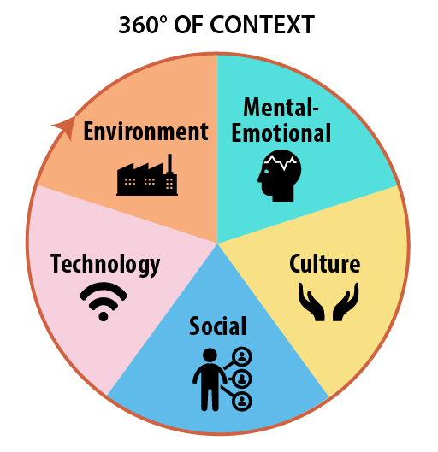Contexts of Learning
Environment | Students can investigate how electronics are used to monitor and improve environmental sustainability through projects such as smart gardens, automated lighting, temperature sensors, irrigation systems, and energy-efficient devices. Students also learn responsible management of electronic waste and sustainable use of materials and components.
Mental-Emotional | Electronics develops resilience, patience, and problem-solving skills as students troubleshoot circuits, debug code, and improve prototypes through trial and error. Successfully completing practical projects helps build confidence, independence, and a growth mindset while encouraging students to manage frustration positively during challenging tasks.
Culture | Students can explore how technology supports communities and reflects cultural values within Aotearoa New Zealand and globally. Opportunities exist to incorporate Mātauranga Māori perspectives, such as kaitiakitanga, through sustainable design or the use of electronics to support local community projects and culturally responsive outcomes. Collaborative learning also supports whakawhanaungatanga and shared knowledge-building.
Social | Electronics projects encourage teamwork, communication, and collaboration. Students often work together to solve problems, test systems, and provide peer feedback. The programme also explores how electronic technologies influence society, including automation, communication systems, robotics, and the ethical impacts of emerging technologies on people and communities.
Technology | The programme directly develops understanding of electronic systems, embedded programming, automation, and digital technologies. Students progress from basic circuits and microcontrollers to more advanced Arduino programming and senior electronic systems development aligned with NZ Digital Technologies Achievement Standards and future technology career pathways.

Local Curriculum Links |  | Mātauranga Māori
Environmental Monitoring Projects – Students could design simple electronic systems using micro:bits or Arduino sensors to monitor rainfall, river levels, temperature, or humidity, reflecting the importance of the Hokitika River and West Coast environment.  Pounamu Industry Connections – Explore how modern technology and electronics are used in machinery, design tools, laser cutting, and security systems connected to local pounamu carving and tourism industries.  Tourism and Safety Technologies – Students could investigate and prototype electronic systems used in tourism, such as automated lighting, information displays, alarms, or environmental sensors relevant to Hokitika Gorge, local museums, or outdoor recreation.  Natural Hazard Technologies – Given the West Coast environment, students could explore electronics used in flood warnings, weather stations, earthquake monitoring, and emergency alert systems. Students could prototype warning systems using LEDs, buzzers, and sensors.  Local Conservation Projects – Partner with local environmental or conservation groups to create simple monitoring systems for school gardens, native planting projects, or compost systems.  Agriculture and Farming Technologies – Investigate how electronics and automation are used in West Coast farming industries, including irrigation, electric fencing, tracking systems, and environmental monitoring.  Community Problem-Solving Projects – Students identify a local issue within Hokitika or the school community and design an electronic solution, such as automated recycling reminders, bike safety lights, or classroom monitoring systems. |  | Kaitiakitanga through Technology – Students design systems that support guardianship of the environment, such as smart plant watering systems, water-level monitors, or energy-saving devices linked to caring for whenua and natural resources.  Māori Environmental Knowledge (Maramataka) – Students can investigate how traditional Māori environmental observation and seasonal cycles compare with modern sensor technologies used to monitor weather, gardens, or ecosystems.  Traditional and Modern Communication Systems – Compare how information was traditionally communicated and observed in Māori society with modern electronic communication systems, sensors, and digital technologies.  Whanaungatanga in Collaborative Design – Students work collaboratively in shared problem-solving tasks and community-focused projects, reflecting collective responsibility and learning together.  Design Inspired by Māori Patterns and Storytelling – Students could incorporate Māori visual design elements, symbols, or storytelling into the casing, display, or presentation of their electronic projects.  Exploring Māori Innovation and Engineering – Discuss how Māori traditionally adapted technologies and tools to suit their environment, linking this innovation mindset to modern electronics and digital technologies.  Te Reo Māori in Technology – Encourage the use of bilingual labels, commands, project names, and documentation within electronic projects and classroom displays.

Skills
Literacy:  Structured Literacy | Reading circuit diagrams and technical instructions; interpreting datasheets and component labels; using appropriate technical vocabulary; writing project documentation, reflections, and evaluations; explaining design decisions; following step-by-step processes; developing programming literacy by reading and understanding code syntax; using keywords and symbols accurately. Structured literacy opportunities include sequencing instructions, decoding technical terms, and using subject-specific vocabulary consistently.
Numeracy: | Measuring voltage, resistance, and current; calculating values using basic formulas; understanding scale and measurement; estimating component requirements; timing sequences in programming; interpreting graphs and sensor data; applying logical and computational thinking; using ratios and percentages in resistor colour codes and electronic calculations.
Digital Tech: | Programming micro: bits and Arduino controllers; debugging code; computational thinking; understanding inputs, outputs, and automation systems; using block-based and text-based programming; data collection through sensors; file and project management; iterative design and testing; understanding embedded systems and electronics integration.
Practical: | Building circuits using breadboards; soldering components safely and accurately; using electronic tools and testing equipment such as multimeters; assembling and prototyping electronic systems; troubleshooting hardware faults; safe workshop practices; cable management and component organisation; designing and constructing functional electronic outcomes.
Problem Solving & Critical Thinking | Diagnosing faults in circuits and programs; testing and refining prototypes; evaluating the effectiveness of designs; applying logical thinking to solve electronic and programming challenges; adapting designs based on feedback and testing results.
Collaboration & Communication | Working in teams on electronic projects, giving and receiving peer feedback, presenting completed projects, explaining technical concepts to others, and supporting classmates during troubleshooting and practical activities.
Creativity & Innovation | Designing original electronic solutions; integrating sensors, LEDs, displays, and automation into projects; experimenting with different approaches; combining hardware and software creatively to solve authentic problems.
Health & Safety Skills | Understanding safe use of soldering irons, electrical components, and workshop equipment; identifying hazards; following safe operating procedures; maintaining tidy and organised workspaces; responsibly handling electronic waste and materials.
Career & Future-Focused Skills | Developing foundational skills linked to electronics, engineering, robotics, automation, IT, and digital technology careers; understanding how electronic systems are used in modern industries and everyday life.

Health & Safety - Link
Computing Room
Safety Issues | Safety Issue | Health & Safety Considerations within Electronics
 | Soldering Equipment | Risk of burns from soldering irons and hot components. Students must be trained in safe soldering techniques, correct handling, safe placement of irons in stands, and allowing equipment to cool before storage. Adult supervision is recommended for junior students.
 | Electrical Safety | Although projects typically use low-voltage systems, students must understand how to safely handle power supplies, batteries, USB connections, and electronic components. Students should never work with damaged cables or exposed wiring.
 | Sharp Components & Tools | Wire cutters, component legs, and small tools may cause cuts or puncture injuries. Students should use tools correctly and safely dispose of trimmed component legs and sharp waste materials.
 | Heat & Fire Hazards | Soldering activities involve heat and potential fire risk. Clear workspace procedures, heat-resistant mats, and safe storage of flammable materials are important. Fire safety equipment should be accessible.
 | Fumes & Ventilation | Soldering may produce fumes that can irritate students. Ensure good ventilation or extraction systems where possible, and encourage students to avoid inhaling fumes directly.
 | Trip & Workspace Hazards | Cables, power leads, and equipment can create trip hazards. Students should maintain tidy workspaces, safely manage cables, and store equipment correctly after use.
 | Tool Misuse | Improper use of screwdrivers, pliers, wire strippers, or hot glue guns may cause injury. Students should receive demonstrations and follow workshop expectations at all times.
 | Component Damage & Short Circuits | Incorrect wiring may overheat components or damage devices. Students should learn correct circuit construction and testing procedures before powering systems.
 | Battery Safety | Incorrect handling of batteries may cause overheating or leakage. Students should use the correct battery types and avoid short-circuiting battery packs.
 | Computer & Ergonomic Safety | Extended programming and design tasks require safe computer use, including correct posture, regular movement breaks, and safe use of shared digital equipment in the computing room.
 | Personal Protective Equipment (PPE) | Safety glasses may be required during soldering or cutting wires. Closed footwear and tied-back hair should be encouraged during practical work.
 | Safe Behaviour Expectations | Students must follow all workshop and computing room expectations, including no horseplay, respect for equipment, immediate reporting of hazards, and use of tools only for their intended purpose.
 | Environmental Safety | Electronic waste and damaged components should be disposed of responsibly. Students should understand

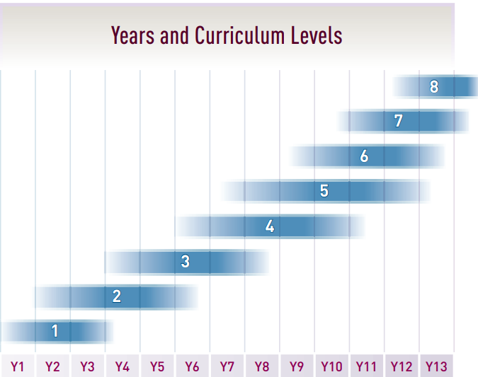 |  |  | New Zealand Curriculum Achievement Objectives  Link
Year 9 & 10 |  | LEVEL 4 | LEVEL 5 | LEVEL 6

Technology Strand | Level 4 (Typically Year 9) | Level 5 (Typically Year 10) | Level 6 (Extension / Advanced Year 10 & Pathway to Senior)
Planning for Practice | Students undertake planning to manage practical electronics projects, including selecting components, following circuit diagrams, and managing time and resources when constructing simple electronic outcomes. | Students plan, review, and adapt stages of electronic development projects, considering testing, programming, and construction processes to ensure successful outcomes. | Students critically plan and organise complex electronic projects, adapting procedures and resources in response to testing, stakeholder feedback, and technological challenges.
Brief Development | Students describe the purpose and key attributes of an electronic outcome that meets an identified need or opportunity. | Students develop briefs that specify electronic outcomes, including functionality, usability, and stakeholder considerations. | Students justify and refine electronic project specifications based on feedback, testing, and the suitability of the final technological outcome.
Outcome Development & Evaluation | Students develop and test electronic systems, such as breadboard circuits or simple programmed systems, and evaluate how well they function. | Students trial and evaluate Arduino or soldered electronic systems to determine fitness for purpose and identify improvements. | Students evaluate electronic outcomes in terms of effectiveness, reliability, usability, and future implications while iteratively refining prototypes.
Technological Modelling | Students use sketches, diagrams, breadboard layouts, flowcharts, and testing to explore electronic ideas before construction. | Students use functional modelling, such as simulations, coding tests, and prototype circuits, to predict and improve system performance. | Students critically evaluate modelling decisions and use evidence from testing and simulations to justify design refinements.
Technological Products | Students understand the properties of electronic components such as LEDs, resistors, switches, and sensors, and how these components influence outcomes. | Students analyse how materials, components, and construction techniques impact electronic product performance and durability. | Students evaluate the suitability of electronic components, materials, and manufacturing techniques for specific technological applications.
Technological Systems | Students understand how inputs, outputs, and control systems work together in simple electronic systems using micro: bits or basic Arduino projects. | Students analyse electronic systems involving sensors, automation, and programmed control, and understand the relationships between system components. | Students evaluate and refine complex electronic and embedded systems, considering reliability, feedback systems, automation, and system interactions.
Characteristics of Technology | Students understand that technology develops through innovation and changes over time to meet people’s needs and opportunities. | Students examine how electronic technologies influence society and how societal needs influence technological development. | Students critically analyse the impacts, risks, and benefits of emerging electronic technologies within local and global contexts.
Characteristics of Technological Outcomes | Students recognise that electronic outcomes are designed for a purpose and can be evaluated for fitness for purpose. | Students understand how design choices affect the acceptability and effectiveness of electronic outcomes for users and stakeholders. | Students evaluate how electronic technological outcomes evolve over time and how they may be adapted for changing needs and future developments.

Juniors | Breadboard | Breadboard Activities:  - Basic Circuit  - NPN/PNP Circuit  - 555Timer Chip Circuit
Juniors | Micro::bit | Micro::bit Activities:
Middle | Soldering | Soldering Activities:  - Strips  - Paper Switch  - Greeting Card
Middle | Printed Circuit Boards (PCB) | PCB Activities:  - 10-LED Flasher  - PICAXE |  | Assembling the Surplustronics 10 LED Flasher kit represents a fundamental, beginner-level experience with Printed Circuit Board (PCB) technology. It involves inserting components through a pre-etched, labelled fibreglass board, followed by soldering them to the copper tracks.
Middle | Ardunio | Arduino Activities:  - Sainsmart Training System
Senior | Assessment | Electronic Techniques |  | L2 - 91894 - (6) Use advanced techniques to develop an electronics outcome  L3 - 91904 - (6) Use complex techniques to develop an electronics outcome

JUNIORS (Term = only have 2 weeks = 4 hours) - Biennial
 | Breadboard Activities:
1 | Basics of Breadboards:  Students will develop an understanding of basic electronic circuits and components by designing, simulating, and constructing circuits using TinkerCAD and physical breadboard equipment. Students will learn how electronic components work together within a circuit and apply safe, practical workshop skills to create functional electronic outcomes. | By the end of this lesson/unit, students will be able to:  Identify and describe the purpose of common electronic components, including LEDs, resistors, switches, batteries, capacitors, transistors, and breadboards.  Explain how a basic electronic circuit works, including the flow of electricity through a complete circuit.  Demonstrate safe use of electronic tools, components, and workshop equipment during practical activities.  Follow circuit diagrams and breadboard layouts accurately to assemble working electronic systems.  Test, troubleshoot, and refine electronic circuits to ensure they function correctly.  Extend understanding of electronics by exploring advanced circuits involving transistors, capacitors, and 555 timer integrated circuits. | * Basic Circuit
2 | Using TinkerCAD - circuits:  Students will develop foundational skills in electronic circuit design and simulation by using Tinkercad to create, test, and modify circuits involving breadboards, LEDs, batteries, micro:bits, and Arduino systems. Students will build confidence in computational thinking, circuit construction, and digital technologies through interactive tutorials and practical experimentation. | By the end of this lesson/unit, students will be able to:  Use Tinkercad to complete introductory circuit simulation tutorials.  Construct a basic LED circuit digitally in TinkerCAD and physically on a breadboard using electronic components.  Apply basic Ohm’s Law concepts when constructing and testing simple electronic circuits.
 | Micro::bit Activities:
3/4 | Basics of Microbits | By the end of this lesson/unit, students will be able to:  Explore micro: bit applications by completing at least one tutorial involving LED matrices, sensors, buttons, breadboards, or external components. | * Flashing Heart  * Name Flasher  * Soil Moisture Tester

MIDDLE SCHOOL (Semester = 10 weeks = 30 periods)
 | Soldering Activities:
1 | Basics of Soldering |  | * Strip soldering  * Paper Switch  * Greeting Card
2
3
 | PCB Activities:
4 | 10-LED Flasher
5 | PICAXE
6
 | Arduino Activities: | Explore Arduino-based electronic systems through selected tutorials on sensors, inputs, outputs, and interactive projects.  Save, download, and submit completed circuit files and evidence of learning using Gmail or the classroom learning platform.  Demonstrate safe and responsible use of digital technologies and electronic simulation tools throughout the learning activities.
7
8
9
10

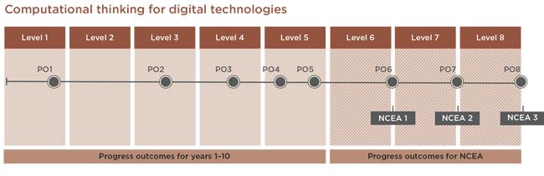 |  |  | Reporting & Assessment Link
SLOs
- Computational Thinking - Coding
Year 11 | PO6 | In authentic contexts, with end-users in mind, students determine and compare the computational complexity of two iterative algorithms for the same problem size. They understand the concept of compression coding for different media types, its typical uses, and how it enables widely used technologies to function.  Students use an iterative process to design, develop, document and test basic computer programs. They apply design principles and usability heuristics to their designs and evaluate user interfaces against them.
Middle School | PO4 | In authentic contexts and with end-users in mind, students decompose problems to create simple algorithms using the three fundamental building blocks of programming: sequence, selection, and iteration. They implement these algorithms by creating programs that use inputs and outputs, sequences, basic selection using comparison operators, and iteration. They debug simple algorithms and programs by identifying when things go wrong with their instructions and correcting them, and they can explain why things went wrong and how they fixed them.  Students understand that digital devices represent data using binary digits and have methods for detecting errors in data storage and transmission. They evaluate the efficiency of algorithms, recognising that computers need to search and sort large amounts of data. They also evaluate user interfaces in terms of their efficiency and usability.
 | PO5 | In authentic contexts and with end-users in mind, students independently decompose problems into algorithms. They use these algorithms to create programs with inputs, outputs, sequences, and selections that utilise comparative and logical operators, variables of different data types, and iterations. They determine when to use other types of control structures.  Students document their programs using an organised approach for testing and debugging. They understand how computers store more complex data types using binary digits, and they develop programs that consider human-computer interaction (HCI) heuristics.

- Middle School  - L2 - 91894 - (6) Use advanced techniques to develop an electronics outcome  - L3 - 91904- (6) Use complex techniques to develop an electronics outcome | ACHIEVED |  |  |  | Use advanced techniques to develop an electronics outcome.
 | MERIT |  |  |  | Use advanced techniques to develop an informed electronics outcome.
 | EXCELLENCE |  |  |  | Use advanced techniques to develop a refined electronics outcome.
Middle School
- Computational Thing - Coding  - Design and develop a digital outcome | 4P | Achieved | C | 50%
 | 4A |  | C+
 | 5B | Merit | B | 70%
 | 5P |  | B+
 | 5A | Excellence | A | 90%
 | 6B |  | A+
Level 1
Level 2
- L2 - 91894 - (6) Use advanced techniques to develop an electronics outcome | Use advanced techniques to develop an electronics outcome involves:  ● using appropriate resources and techniques to develop a functional electronics outcome  ● testing and debugging to ensure that the electronics outcome performs to specifications  ● explaining the interfaces and functions of components and systems  ● explaining relevant implications.  Use advanced techniques to develop an informed electronics outcome involves:  ● identifying the behaviour and function of the electronics outcome  ● testing and modifying to ensure the reliability of the electronics outcome  ● evaluating the choice of components and systems used  ● addressing relevant implications.  Use advanced techniques to develop a refined electronics outcome involves:  ● undertaking iterative improvement throughout the design, development and testing process to produce a high-quality electronics outcome  ● justifying the choice of components and systems used.
Level 3
- L3 - 91904- (6) Use complex techniques to develop an electronics outcome | Use complex techniques to develop an electronics outcome involves:  ● using appropriate resources and techniques to develop a functional electronics outcome  ● constructing, testing, and analysing functional circuits to ensure that the electronics outcome performs to specifications  ● testing, modifying, debugging the outcome  ● explaining the behaviour and function of the electronics outcome  ● explaining relevant communication protocols  ● addressing relevant implications.  Use complex techniques to develop an informed electronics outcome involves:  ● using information from testing and analysis to ensure the circuit(s) functions reliably.  Use complex techniques to develop a refined electronics outcome involves:  ● undertaking iterative improvement throughout the design, development and testing process ● justifying the choice of communication protocols ● justifying the choice of components and subsystems

Unit Evaluation
What went well?
What didn’t go well?
What changes do I need to make?
How will I gather information about the impact of these changes in my practice?
Did the changes made from last time make a difference?
What are the next steps for my learning and development?
Other comments

